Local agreement at Finnish workplaces

Summary of study:

The power of the owners and dialogue
Local agreement at Finnish workplaces
Final report on project
The Central Organisation of Finnish Trade Unions - Jyrki Helin
Jyväskylä 1998

To the reader

Local agreement at workplaces is commonplace in Finland. It is made possible by the high level of union membership: over eighty per cent of wage-earners belong to a trades union. The employers are also extensively organised.

Beside comprehensive union membership, local agreement is also facilitated by a broad network of shop stewards. Approx. eighty per cent of the members of the Central Organisation of Finnish Trade Unions have a shop steward. Workplaces without a shop steward are mainly small, with fewer than ten employees. The shop stewards have a key role to play: they are the representatives at the workplace of the workers that have elected them in relation to the employer, and they also represent their union and monitor the collective agreement at the workplace.

The national collective agreements delegate, i.e., transfer power of agreement to the workplaces. The collective agreements provide a framework which constitutes a minimum requirement, but, on the other hand, contract clauses can be applied at workplaces fairly broadly. The local agreements cannot run counter to labour legislation, i.e., the protection provided by the law is a minimum which must be adhered to.

There has been an increase in local agreement. Pressures are created by fierce changes in working life. Workplaces must be constantly equipped for situations of change, which are reflected not only in the performance of the work but also in remuneration and other employment benefits. On the other hand, employees must themselves play a more active role in changing work processes.

The precondition set by the Central Organisation of Finnish Trade Unions for extending local agreement is that a shop steward is to be elected for each workplace. At present, one obstacle to election is often the employer's negative attitude, or that the personnel cannot find anyone among them who wishes to take up the position. The Central Organisation of Finnish Trade Unions will help promote local agreement only if the shop steward's equal position is secured. Generally speaking, shop stewards already enjoy the protection of the law, collective agreements and agreements concluded by the labour market central organisations. Nevertheless, the rights of the shop steward are nowhere near the level which the Central Organisation of Finnish Trade Unions is aiming for. This being the case, local agreement is gradually expanding at the same time as shop stewards' rights are increasing.

This summary of the study by the Central Organisation of Finnish Trade Unions is a comprehensive account of the routine aspects of local agreement at Finnish workplaces in the late 1990s.

Helsinki, 3rd February.1999

Jyrki Helin
Research Secretary at the Central Organisation of Finnish Trade Unions

The collective agreement system in Finland

(Unice, Ceep European-level agreement ETUC)
(European Sectoral European agreement Professional secretariats) employers' unions

Employers' Centralised agreements Wage-earners'
central organisations General agreements central organisations

Employers' union Collective agreement Trade union

Company Local agreement Shop steward

Company Employment contract Employee

The collective agreement has a key role to play. The centralised agreement is always concretised as the collective agreement. Local agreement takes place, as a rule, within the limits of the collective agreement.

The system is also a system for negotiating conflicts. Arguments over interpretation are ultimately settled at a special court, the Industrial Tribunal.

The background to the study

In spring 1996, the Central Organisation of Finnish Trade Unions initiated a study into local agreement, with the participation of seven trades unions: the Chemical Workers' Union, the Trade Union for the Municipal Sector, the Union of Commercial Employees, the Metalworkers' Union, the Construction Trade Union, the Finnish Media Union and the Finnish Electrical Workers' Union. The study was comprehensive, since the public and private service sectors and industry were broadly represented.

As part of the preliminary study, the legal and contract clauses of local agreement in the field of each participating union were examined. The unions' experts on local agreement were interviewed and the attitudes of both members and the Finnish people as a whole towards local agreement were ascertained.

New information was gathered through a questionnaire targeted at shop stewards in late 1996 - early 1997. As there was a need to obtain a more in-depth view than that obtained from the questionnaire study from both workplace shop stewards and the employers, an interview study was also conducted at 44 workplaces in seven different sectors. The study involved workplaces of varying sizes.

Long traditions

Local agreement has been carried out in Finland for a century − during the same period in which there has been extensive union membership by workers. The first agreements were specific to a workplace: the terms of employment for a specific profession in a specific locality were agreed upon.
With the exception of the graphical industry, national collective agreements only became common practice after the Second World War, i.e., they have a history dating back about fifty years. The agreements by the unions and central organisations strengthened their position from the closing years of the 1960s, when the mass force of the trades union movement grew.

Yet, above all, the position of the collective agreements grew stronger with the new Contracts of Employment Act at the beginning of the 1970s. In the same period, local agreements were also common practice.

Local agreement takes a variety of forms

Local agreement refers to an agreement concluded at a workplace or in a company or to a network of such agreements. Local agreement cannot come into conflict with binding legal or collective agreement clauses.

Terms of employment are governed by an order of priority whereby an ordinance of a lower degree must not undermine a worker's benefits granted at a higher degree. In practice, the rule of greater advantage must also be adhered to, i.e., the source of regulation most advantageous to the employee. This is based on the principle of employee protection.

For example, the collective agreement regulations are generally minimum regulations, whose terms must be complied with. If a local agreement forms part of a collective agreement, the matters negotiated in the local agreement are norms on a par with the collective agreement.

The order of priority of conditions of employment

- Absolute legal provisions.
- The norms of a generally binding collective agreement that must be complied with under the Contracts of Employment Act.
- The norms of what is known as an ordinarily binding collective agreement that must be complied with under the Contracts of Employment Act.
- Semi-dispositive (semi-obligatory) legal provisions to which exceptions may be made in a collective agreement.
- Employment regulations (and corresponding co-operation agreements).
- The terms of a contract of employment and practices comparable to an agreement
- Norms of a collective agreement which can be negotiated differently at local level.
- Dispositive (discretionary) legal ordinances.
- The norms of ordinary law.
- An employer's orders within the framework of direction law (work management and supervision).

Local agreement refers to an agreement concluded by the employees - a collective or individuals - at a workplace or in a company, which affects the terms of employment. It constitutes the result of the concurrence of the parties' will and bilateral arbitration, or "bargaining". Some collective agreements also require agreement in writing.

In terms of labour law, the methods of agreement at local level are:
- contracts of employment, comparable agreements and practices on a par with an agreement
- agreements emerging out of co-operation procedures
- the local agreements referred to in a national collective agreement
- collective agreements specific to a company
- other agreements to which at least the general rules and principles of the laws of obligations and contract can be applied (”some other agreement under the law of obligations", e.g., the terms of service of a person in a prominent position)
- in practice often a combination of the preceding

Local agreement according to a narrow concept is represented by separate agreement on the basis of a national collective agreement. The broad view, for its part, incorporates the previous list in its entirety and also the situations which arise in routine work, which result in assents and common understandings. These make the production process and the work of the employees smoother. They can also be used within the company to develop the terms of employment independently, in the best cases taking bilateral interests into account.

The trades union movement seeks equality

The employer would prefer to look upon local agreement as forming part of distribution issues (salaries, working hours) but not of production issues (the employee's opportunities for developing his or her own work and work processes) and under no circumstances as intervention in management power (and direction right).

The Central Organisation of Finnish Trade Unions takes a broad view of local agreement. The trades union movement and the employees are granted a positive opportunity precisely in that the wage-earners also have a voice in matters relating to management and production.

The Central Organisation of Finnish Trade Unions has noted that matters to be agreed upon within each company include the introduction of new technology and the ensuring amendments to the terms of employment, the contents and organisation of work, certain arrangements relating to working hours, company-specific applications relating to methods of remuneration, and equality, training, relocation and environment issues. The condition is that the wage-earners' position as an equal negotiating party at the workplace is to be safeguarded.

Citizens' support for collective agreements

According to studies carried out by Suomen Gallup Oy, two-thirds of Finns consider that very extensive agreement at the workplace favours the employer and would be disadvantageous for the employees. Collective contractual protection, developed and supported by the representative labour market organisations, receives the support of the overwhelming majority of citizens. The opinion of citizens was tested by means of the questions: "The employers ought to be entitled to hire employees on the terms under which the employees personally consent to perform the work without any collective agreements" and "Agreement on the minimum terms of employment (e.g., remuneration and periods of notice) should be reached by means of collective agreements, since the individual employee is in no position to agree equally on his or her remuneration with the employer ”.

The Central Organisation Of Finnish Trade Unions' shop stewards and local agreement

Union activists undergoing training at the Central Organisation of Finnish Trade Unions' colleges were asked about their experiences of local agreement between October 1996 and March 1997. The investigation provided the shop steward's viewpoint on the state of local agreement.

The group studied was distinctly more industry-oriented than the membership distribution of the Central Organisation of Finnish Trade Unions: approx. seventy per cent of respondents were from industrial unions, whose members account for over forty per cent of the Central Organisation of Finnish Trade Unions' membership. Approx. twenty per cent of respondents are representatives of private services, which account for approx. thirty per cent of the Organisation's membership. Approx. ten per cent of respondents are representatives of the public sector, which account for around thirty per cent of the Organisation's members.

72 per cent of the respondents were men and only 28 per cent women. Women account for 46 per cent of the members of the unions in the Central Organisation of Finnish Trade Unions.

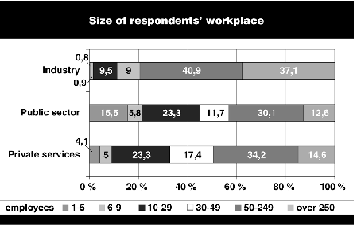
Workplace size

When divided according to workplace size, the respondents from industry are clearly from larger workplaces than the others. This investigation again provided confirmation for the fact that the gaps in shop stewards' activity are at small workplaces.

In 1995, less than eighty per cent of the members of the Central Organisation of Finnish Trade Unions had a shop steward, but only 56 per cent at workplaces with fewer than thirty employees. Organisation studies carried out by the Central Organisation of Finnish Trade Unions have demonstrated that more than forty per cent of its members work at workplaces with fewer than thirty employees, but in this study material fewer than twenty per cent of the shop stewards were from workplaces of that size.

When divided according to the position of responsibility, the largest group consists of workplace shop stewards: they accounted for 44 per cent of the total. Approx. seventy per cent of respondents held a steward's position that is important as regards local agreement. The positions of responsibility add up to over a hundred per cent because the same people may hold shop steward's, labour protection and local union posts. The majority of the chief shop stewards who replied work in industry, the majority of labour protection delegates in private services and the majority of workplace shop stewards in public services.

Chief shop steward or deputy shop steward 26.0 %
Shop steward or deputy shop steward 43.8 %
Labour protection delegate or deputy labour protection delegate 23.3 %
Labour protection representative or deputy labour protection representative 21.3 %
Member of local union committee 29.5 %
Member of shop, local union, committee, lobbying group,
workplace committee, labour protection committee etc. 19.2 %

Local agreement is common

The study focusing on shop stewards describes the local agreement situations in that segment of working life where the trades union movement provides training and operates in practice and where the employer strives for co-operation. The analysis thus covers the "better half" of Finnish working life. In all probability, the state of the other half of Finnish working life is less favourable from the employees' standpoint.

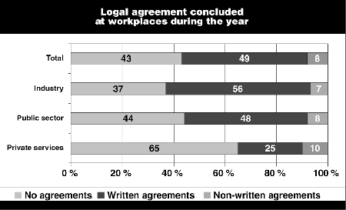
Local agreement concluded at the workplace in the course of a year

Broadly defined, there is local agreement at more than half of the workplaces. The highest number of local agreements are in industry, at approx. 63 per cent of workplaces. In the public sector, approx. 56 per cent of workplaces and in private services approx. 35 per cent of workplaces agree locally.

There were written local agreements at 49 per cent of workplaces, most commonly in industry.
The interview study conducted at the workplaces demonstrates that local agreement is more extensive in working life routine than the shop stewards would lead one to believe.

The themes covered by local agreements

The commonest local agreement concerns amendments to the contents of contracts of employment. Less common are separate agreement on the basis of a collective agreement, salary agreements specific to a workplace, local collective agreements, other local agreements and, finally, agreement according to the Co-operation Act. The initiative in all these categories is generally always taken by the employer, which is natural since local agreement is usually designed to achieve more productive practices at the workplace.

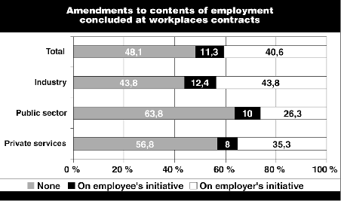
Amendments to the contents of employment contracts made at workplaces

The contents of employment contracts have been amended the most in industry, where the phenomenon was familiar at the majority of workplaces. 44 per cent of these changes occurred on the initiative of the employer and 12 per cent on that of personnel. The contents of employment contracts were amended the least in the public sector, with the employer generally taking the initiative.

The study did not ask directly how the employment contracts had been altered. Other sources and other answers included in this study lead one to conclude that the changes have concerned working hours, the extent of duties, transfers from one set of duties to another, and remuneration.

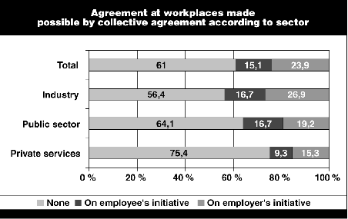
Agreement specific to a workplace made possible by collective agreements, according to sector

Separate agreement made possible by a collective agreement was encountered most in industry, second most in the public sector and least in the service sector. As a rule, the initiative in each sector was taken by the employer. In the public sector, the level of initiative displayed by the employees was closer to that of the employers. This is a sign of the active role played by the Trade Union for the Municipal Sector in matters relating to the contents of work and in other "operational" issues in the municipalities.

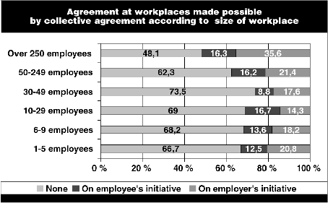
Agreement specific to a workplace made possible by a collective agreement, according to the size of the workplace

Separate agreement was commonest at the largest workplaces, with over half of them engaging in it. Separate agreement was least commonly employed at workplaces with 30-50 employees.

Personnel were the most active, relatively speaking, at workplaces with 10-30 employees, where their level of initiative exceeded that of the employer. This can be explained by the operational development of the fairly small workplaces in the public sector and by the activeness of industrial workplaces in matters relating to working hours and remuneration.

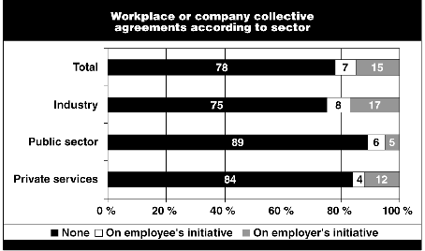
Collective agreements specific to a workplace or company, according to sector

Collective agreements specific to a workplace were familiar to a quarter of industrial workplaces, and distinctly less familiar for other sectors. Collective agreements specific to a workplace or company are commonest whenever an employer that does not belong to a union accedes as an individual employer to the national collective agreement in its sector. This practice prevails, e.g., in the transport and construction sectors.

Another common form is a collective agreement specific to a company with a particularly large company operating in the sector. The third type is at state workplaces organised along the lines of a business enterprise.

In this investigation, the large number of collective agreements specific to a company nevertheless suggests that the shop stewards have included in this category those local agreement made possible by a collective agreement, which under the union's collective agreements practice have become part of the collective agreement. The initiative in collective agreements specific to a workplace is first taken by the employer.

Out of the forms of local agreement, collective salary agreements specific to the workplace had been concluded at approx. one third of workplaces. As a rule, these had emerged on the employer's initiative (21%), but the personnel had also been active (15 %).

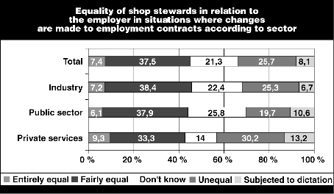
Equality of shop stewards in relation to the employer in a situation where amendments are made to employment contracts, according to sector

Equality in negotiating situations is one condition of effective local agreement. Shop stewards that had taken part in local talks were asked for their personal views on the matter. Amendments to employment contracts had been encountered by approx. 52 per cent of shop stewards.

In situations involving amendments to an employment contract in the service sectors, 42.6 per cent considered that they had been in an entirely or fairly equal position during the talks. On the other hand, roughly the same percentage of shop stewards in the service sectors deemed that they had been in an unequal position or subjected to dictation.

In the public sector, 44 per cent estimated that their position had been equal and thirty per cent that it had been more or less unequal.

In industry, 46 per cent considered that their position had been equal and the opposite opinion was held by 32 per cent. Women experienced inequality to some degree more than men in negotiating situations; women also gave more "don't know" responses.

The size of the workplace has an effect on the employee's negotiating position. At workplaces with fewer than ten employees, the negotiating situation appears to be the most unequal, and it would appear that shop stewards at workplaces with 10-50 employees are most clearly subjected to dictation. In this respect, the low number of shop stewards from the smallest workplaces - a total of 35 respondents - may distort the statistical analysis.

Bearing this in mind as well, the situation with regard to negotiating the contents of employment contracts appears, in the eyes of the shop stewards, to be best at the smallest and largest workplaces.
The most traditional features of the power of the owners continue to prevail at Finnish workplaces. Greater inequality is experienced in situations where amendments are made to employment contracts than in separate agreement on the basis of a collective agreement.

The conclusion is that the greater the norm protection provided by the collective agreement, the more equal the negotiating situation is. Nonetheless, even in negotiations enjoying stronger norm protection there is still a long way to go to the only natural situation - equality - in all sectors and in companies of all sizes.

Training limited

Training also has a role to play in the atmosphere at workplaces. In matters relating to local agreement, the employer had arranged training at virtually one in three workplaces. It had been clearly provided the least in the private service sector.
Sector training arranged (% of workplaces)
Private services 17.9 %
Public sector 32.5 %
Industry 32.5 %
Total 29.7 %

The shop stewards' preparedness

What skills do the shop stewards of the Central Organisation of Finnish Trade Unions have at their disposal for responding to the employer's display of initiative? The issue was investigated from the standpoints of equality and the adequacy of the information received.

The adequacy of the information was determined by asking questions relating to the various aspects of local agreement: "Has the information provided by the employer been adequate prior to talks?". The shop stewards' ability to act in negotiating situations and the adequacy of the information obtained during them was also investigated separately. Receiving information on the matter under negotiation from the employer is not a foregone conclusion. Least adequate was the information provided in private service sectors. On the other hand, the best information was received at the smallest and largest workplaces. In collective agreement negotiations specific to a workplace and in negotiations under the Co-operation Act, women felt that they had received less information compared to their male colleagues.

perfectly fairly Don't fairly No information
adequate adequate know limited received at all

alteration to contents
of employment contract 15.7 % 33.3 % 17.3 % 28.8 % 4.8 %

co-operation under the
Co-operation Act and
a co-operation agreement 10.8 % 21.1 % 44.5 % 17.8 % 5.9 %

Local agreement made
possible by a collective
agreement 13.8 % 32.2 % 26.4 % 21.9 % 5.7 %

collective agreement
specific to a workplace
or company 11.2 % 28.6 % 37.0 % 17.1 % 6.1 %

salary agreement specific
to a workplace 12.2 % 31.2 % 30.4 % 19.5 % 6.7 %

other agreement 12.4 % 29.0 % 36.6 % 16.3 % 5.7 %

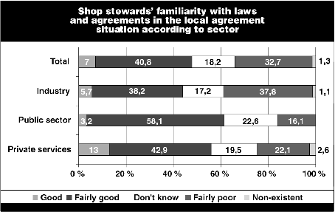
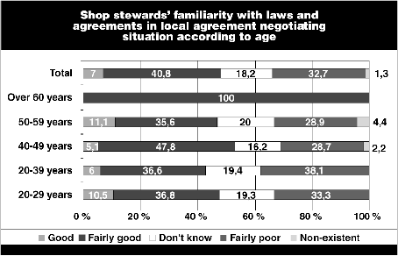
Shop stewards' familiarity with laws and agreements

Out of the shop stewards that had been involved in negotiating situations, 48 per cent estimated that their knowledge of laws and agreements was fairly good, 34 per cent as poor or non-existent, with the rest being unable to evaluate their level of knowledge. 30-40-year-olds deemed their familiarity with the norms to be lower than average.

According to sector, the personal assessment of expertise ranks highest in the public sector, followed in order by private services and industry. The higher age and greater experience of public sector shop stewards and ordinance control characteristic of the sector probably explain the phenomenon.

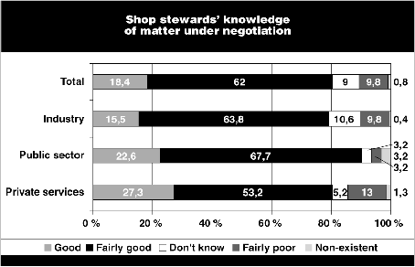
Shop stewards knowledge of the matter under negotiation

Eighty per cent considered that their knowledge of the matter under negotiation was very adequate or fairly adequate, eleven per cent that it was poor or non-existent. There were no appreciable differences between groups.

The "fairly poor" and "not at all" columns combined total 14.3 per cent in private services, 6.4 per cent in the public sector, 10.2 per cent in industry and 10.6 per cent in all sectors together.

At its highest, the "not at all” percentage is 3.2 in the public sector. All told, the shop stewards had ascertained the facts relating to the matter under negotiation quite well.

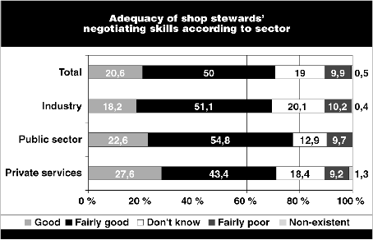
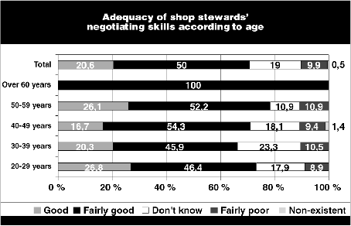
Adequacy of shop stewards' negotiating skills according to sector

Seventy per cent of the shop stewards deemed their negotiating skills to be adequate or fairly adequate. Those under thirty and over fifty assessed their negotiating skills to be better than others'.

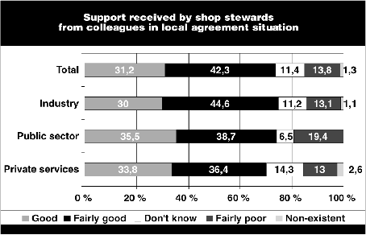
Support received by shop stewards from their colleagues

Three-quarters of shop stewards received good or fairly good support from their colleagues, and fifteen per cent received poor support. Solidarity was strongest in industry and the public sector; in the private services the number of people responding with "don't know" was slightly higher.


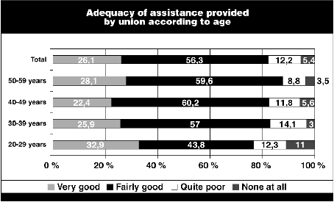
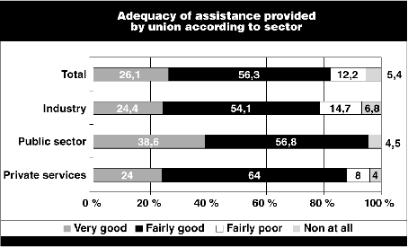
Requesting guidelines from union

43 per cent had been in touch with their own trades union on matters of local agreement. The age distribution demonstrates that the older and often more experienced shop stewards were the most active users of union services; the majority of 40-60-year-olds had been in touch with their union..

A full 82 per cent of those who had been in touch with their union were very or fairly satisfied with the services they had received. The "not at all" option was chosen by a full five per cent. When examined according to age, the most dissatisfied was the group of 20-30-year-olds, where some degree of dissatisfaction was expressed by nearly a quarter of respondents; satisfaction increased with age.

Women (91 %) were more dissatisfied with the service they received than men (80 %). The reason is probably that the relative share of women is high in the public and private service sectors, where there was otherwise the greatest satisfaction with the union's services.

To whom do people turn to for support at workplaces?
The shop stewards first approach their trades union whenever they need support in workplace agreement situations. They seek support almost as often from their colleagues, and then from other shop stewards among the employers and the local union.

The union is regarded as very important at medium sized workplaces with 10-50 employees. The union's support at workplaces smaller and larger than these is also important, with over eighty per cent regarding it as important. It would appear that at the smallest workplaces, the agreement situations are so close to personal interest that the union's agreement monitoring is felt to be more remote.

At the very largest workplaces, the result is probably influenced at both the workplace itself and in the same employer's organisation by the shop stewards' organisation, which is usually strong and capable of taking action.

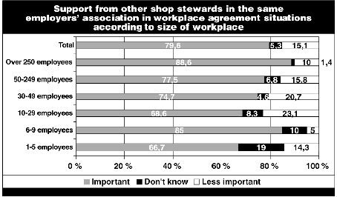
Support from other shop stewards in the employer's organisation

A considerable degree of support was sought from shop stewards in the same employer's organisation at the large workplaces, which also generally have a developed shop stewards' organisation. At workplaces with over 250 employees, 89 per cent of the shop stewards felt that other shop stewards were an important source of support - even more important than the union.

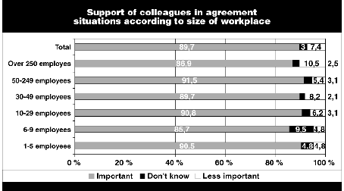
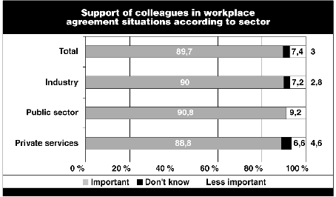
Support from colleagues

The support of colleagues was regarded as roughly equally important in all sectors - approx. ninety per cent deemed it to be important.

Local agreement at workplaces

As part of the study, both shop stewards and employers' representatives at 44 workplaces in various sectors were interviewed.

The interviewed workplaces were divided according to sector in accordance with the total number of personnel as follows:

sector 50 or fewer 51−250 over 251 total

municipal sector 1 1 3 5
commercial sector 1 5 2 8
chemical sector 2 2 2 6
graphical sector 2 3 1 6
metal sector 2 1 4 7
electrical sector 5 2 - 7
construction sector 4 1 - 5
total 17 15 12 44

The municipal sector

The opportunities for local agreement in the municipal sector are particularly extensive. There are numerous levels, ranging from agreements affecting the entire municipality to the formulation of practices in unit-specific work communities.

The collective agreements in the municipal sector allow the local level to deviate fairly extensively from the regulations in national agreements. Furthermore, disputes over the interpretation and application of binding contract clauses are negotiated locally, together with certain general principles or bases of matters subject to deliberation. Some of the terms of a national collective agreement can be negotiated separately at workplaces.
No local agreement can be made on deviating from the average duration of regular working hours, the length of annual leave nor from sickness and maternity leave privileges. The salary must not be negotiated lower than the minimum limits for salary pricing. In the arrangements on working hours, 6-9 hours according to the agreement sector can be set as the length of a shift, with one year as the equalisation period.

Salary revisions affecting various personnel groups are also negotiated locally. Associations which have concluded local agreements and the employer are under an obligation to check that the agreement is not deliberately violated and that the obligation to maintain industrial peace is complied with. Disputes ultimately pass through the unions to an industrial tribunal, even though the agreement actually urges the parties to avoid this path.

The parties to the agreement are the municipality or a municipal federation with the trades union as the opposite party. The chief shop steward cannot sign an agreement unless he or she is also authorised to sign for the union.

Five workplaces of various sizes from all over Finland were involved in the study from the municipal sector.

Example: A central hospital in a large town

The hospital is the biggest in Finland. The management ideology is based upon management by results and on the continuous development of service quality. The production organisation is divided into areas of operation and responsibility. The aim is for the work to be regarded as a process, a "service pipe". There still exists a special hierarchy, but, on the other hand, it incorporates team work.

There are 8,000 employees, approx. 1,800 of whom are members of the Trade Union for the Municipal Sector in basic hospital service jobs. There are several dozen part-time employees on the staff, and a third are working on a fixed-term contract. Of the orderlies that belong to the Trade Union for the Municipal Sector, approx. half are in untypical jobs.

The central hospital abides by the municipal collective agreements, and it also has a local co-operation agreement.

Separate negotiation of the collective agreement has been conducted, inter alia, on the arrangement of work shifts, and approx. 20 separate agreements on working hours have been concluded. The rules on personal remuneration have been agreed upon with personnel, and holiday pay has been replaced by time off. As regards the bonus system, the principles of remuneration and the participation of personnel in the profit centres have been negotiated locally with personnel.

The position of the personnel was deemed by the employer's representative to be equal in both the co-operation procedure and in other local agreement. The shop steward himself did not consider himself to be in an equal position with the employer.

The significance of local agreement for personnel lies, above all, in enhancement of job security. New remuneration and reward systems are under development, working hours' arrangements which meet personal needs are in use, and in production matters the employers are encouraged to display innovativeness. There is a desire to take fitness for work and morale into consideration.

The shop steward expects the trades union movement to win better notification and negotiating rights, i.e., a return to the movement's roots. The minimum terms of employment ought clearly to be entered in national agreements. Flexitime may introduce conflicts among the employees, e.g., between young and old, and the less flexitime there is, the more straightforward the situation will be. If local agreement is extended, the position of the personnel and its representatives ought to be strengthened.

Conclusions from the municipal sector

Without exception, the municipal sector has an effective negotiating system in which the shop stewards reach and cover membership well. The shop stewards are supported by a network of organisations and the union's local agents, with whom there are direct, fast and good relations. The special feature of the sector is that the members of the Trade Union for the Municipal Sector are decision-makers in municipal councils and executive boards.

Local agreement in the municipalities has generally been a reaction to needs to implement cutbacks.

The trades union's strategy is to integrate production matters into lobbying alongside traditional distribution issues. The operating culture nevertheless changes slowly. The shop stewards are increasingly taking up production matters, and it then depends on the employer how quickly and along which lines matters progress.

The commercial sector

The collective agreements of salespersons and warehouse workers, office workers, the barbers' and hairdressers' sector and of pharmacy workers provide opportunities for separate agreement at workplaces. As a general rule, the agreements must be made in writing and the parties can be the employer or its representative or an employee, employees and the shop steward.

It can be agreed at workplace level for, inter alia, working hours to be a maximum of ten hours a day and 48 hours a week. If a shop steward has been elected to the workplace, the matter must be agreed upon with him in writing. The working hours of a warehouse worker can also be arranged so that the maximum duration of regular working hours is ten hours and that there are a maximum of four work days per week.

Meal breaks and the maintenance of work apparel can also be agreed upon locally, e.g., whereby the employees deal with maintenance themselves in return for a time, financial or other compensation.
Under the collective agreement of the barbers' and hairdressers' sector workers, holiday pay can be exchanged for the equivalent time off with pay.

An interview study was carried out at eight workplaces in the commercial sector in various parts of Finland. Two of the workplaces were large, with over 250 employees, and one had fewer than fifty employees, and the rest were medium-sized workplaces.

Example: Two centres in a retail trade chain

The study involved two companies operating with the same product name and belonging to two fairly large regional co-operative retail societies. They are located in different parts of the country, but both are modern shopping centres where the same business concept is in principle applied.

Both organisations have developed teams according to product category or department. The foreman is a coach-cum-instructor, the salesperson is a result-maker, the department foreman checks production, and the director of the company enables the result to be achieved. The organisation has a low profile.

The first company has a personnel of eighty, 30% of whom are men and 70% of whom are women. 80% of them are part-time workers, and approx. 10% are on a fixed-term contract. Temporary staff are also employed. The worker structure can be explained by the fact that the unit was new, and had only just started up its operation. Approx. half of the employees belong to a union. The workers are represented by a shop steward.

The second company has a personnel of 72, fifteen of whom are men, and 57 of whom are women. 55% of the employees are part-timers, and there are only a few people on fixed-term contracts. There are approx. twenty temporary employees, who are students and work on the check-outs. The company operates in a new building, but the personnel have transferred there from an old centre 92 per cent of the employees belong to the Union of Commercial Employees, and they are represented by a workplace shop steward.

One of the companies had two levels of agreement arrangements: one applying to the entire company and the other to a specific workplace. Under the collective agreement, the company as a whole has an agreed work day of ten hours, and the agreement was concluded at head office level. A meal break of thirty minutes has been agreed upon locally, the workers look after their apparel themselves and the employer provides the cleaning equipment.

In the other company, a meal break of thirty minutes had been negotiated, and it had also been agreed that on national holidays occurring during the week, the part-time workers are to be at work and that they should receive a remuneration for working on such a holiday. If there has been a need for a 6-day working week, a temporary verbal agreement has been concluded on the matter. It has been agreed that there are to be two coffee breaks of fifteen minutes in a working day of six hours.

In both companies, the employer considered that the personnel were in a sufficiently equal negotiating position. In one company, the shop steward was of the view that he enjoyed an equal position in local agreement. In the other company, the shop steward considered that the negotiating set-up was not equal because the shop steward only had the right to submit matters, and the power of decision was left to the employer.

Conclusions from the commercial sector

In the commercial sector, union membership is the prevailing trend, albeit not universally, and the shop stewards' system in perishable goods' trade chains is comprehensive. Local agreement in the commercial sector is concluded separately for each chain and is "upper level", and, as a rule, it intervenes in matters regulated in the collective agreement. There is little local agreement at the workplace in response to its specific circumstances.

The companies have a fairly uniform policy on working hours in the perishable goods' trade: a third of personnel are employed full-time, and two-thirds part-time. In many companies, full-time workers are promoted to the ostensible position of foreman and a new hierarchy is thereby created within the workplace.

The graphical sector

The final protocol of the graphical sector's collective agreement notes that the parties are to promote productivity co-operation in companies and, in this spirit, develop local agreement.

As regards the concrete procedures for local agreement, it has been agreed that any issue affecting an individual employee is to be handled by the employee and employer's representative. The employee is always entitled to avail himself of the shop steward's assistance. Any matter affecting a shop or company is dealt with by the shop steward and employer's representative.

Agreements are concluded in writing. Disputes are ultimately settled by a court of arbitration. The chief shop steward and employer's representative can agree on arranging the regular working hours into shifts of a maximum of twelve hours so that they level out to a maximum of fourty hours within a period of working hours. An agreement can also be reached on a separate weekend shift, in which the working hours exceed ten. At the time the study was made, an agreement had to be sent to the unions for their approval; if the unions do not approve an agreement, it is the collective agreement which applies.

When making alterations to the manning of printing machinery, the matter must be negotiated in accordance with the negotiating procedure and "every attempt must be made to reach an agreement". Agreement on staggering coffee and meal breaks is reached locally, to allow the machinery to be run without interruption.

An agreement can be reached locally on compensating for overtime with time off rather than cash remuneration, in which case the percentage increases for over-time are taken into account.

The annual leave can be given at some time other than the annual leave season by agreement between the employer and employee, it can be divided into parts as permitted by the Act on Annual Leave and accumulated more than is permitted by the Act on Annual Leave.

As regards the increase in annual leave pay, it can be agreed for the dates of payment to be deferred, for it to be levelled out over a longer period, for it to be replaced by time off and even for it to be left unpaid if there exist economic or production grounds on a par with grounds for dismissal. Local agreement can be reached on the date of the winter leave and on replacing it with payment.

In connection with the study, six representatives of graphical sector workplaces and employers were interviewed. Two of the workplaces were small companies with fewer than fifty employees, three were medium-sized and one was large, with over 250 employees.

Example: A medium-sized printing company

The company's principal products are periodicals and advertising products. There are approx. a hundred employees, seventy of whom are men. All the workers and office personnel were members of the Finnish Media Union and they were represented by the principal shop steward, deputy shop steward and four shop stewards, one in each shop. There were eight technical employees and one senior clerical employee. The printing machines are operated mainly in two shifts, each of approx. 130 hours a week. A considerable share of production is exported to Russia.

The company has agreed on a reduction in the lunch break on the basis of the Act on Working Hours. The co-operation procedure is employed daily at the company if matters require it.

On the basis of the collective agreement, the company has agreed on manning per machine, extended shifts at weekends and on the payments relating to these. The starting point of weekly work necessary in shift work has also been negotiated locally. The agreements have generally emerged without any difficulties.

The employees organise their work to a considerable extent, in particular in evening, night and weekend shifts. The supervisors are not present, but the production orders can be viewed on a terminal. The employees plan the arrangement of jobs themselves, even orders of raw materials and to some degree liaison with the customer. The work is highly independent, and so it can be said that the employer's supervisory right has been transformed: the employer has relinquished some of its direction right.

The shop steward hoped that the trades union movement would raise the issue of a reduction in working hours. National collective agreements need to be developed, and local agreement solely as a part of the collective agreement.

Conclusions from the graphical sector

The level of union membership in the graphical industry is high. There are gaps in shop stewards' activity at small workplaces. The professionalism of both individual workers and the group is superb, and this is recognised and valued by the employer. A considerable degree of responsibility has been passed on to the employees, and direction right has been transferred downwards.

The union is familiar with virtually all the local agreement in the sector. There is extensive agreement on working hours, with associated agreement on rewards.

The chemical sector

The collective agreements of the chemical industry, glass ceramic industry and vehicle tyre industry refer separately to matters which can be negotiated separately in accordance with the negotiating procedure. The agreements should be made upon request in writing, and a written agreement can remain in force even after the expiry of a collective agreement. An agreement is binding on the employer and upon those employees represented by the shop steward. An individual employee can also be involved in concluding an agreement.

The collective agreement clauses of the shoe and leather industry and of the rubber industry and laundries are identical in terms of content.

The glazing sector agreement grants the right to agree separately on all sections of the collective agreement. The agreements are also concluded in writing. The agreement also contains an article according to which matters are to be negotiated with the employees if the company has no shop steward.

The working hours in a 24-hour period can be temporarily extended whenever the weekly working hours are a maximum of fifty; the working hours' equalisation period is a year. A twelve-hour shift can be introduced with the consent of the unions.

Agreement can be reached locally on the time for having days off which have been accrued in the course of the year, and, likewise, on the positioning of working hours on the eves of a weekday holiday. The meal break can be shortened to half an hour, and a refreshment break can be agreed upon locally.

In the rubber industry, new contract prices are agreed upon with the relevant group of workers at the workplaces. The grounds whereby overtime payment is calculated can be agreed upon locally, likewise receiving overtime payment in the form of time off.

The employer is under an obligation to give prior notice of assignment travel jobs, though an exception can be made to this at local level. If a journey is prolonged, agreement can also be reached on a meal allowance and, overseas, the reductive effect on the daily allowance of living in the place of assignment.

A tool remuneration is to be agreed upon separately if an employee's tools are also used by others. Taking the annual leave outside the holiday season can also be agreed upon, and end-of-holiday pay can be paid in one or several instalments.

The shop steward's use of time at a workplace with fewer than twenty employees is agreed upon locally.

In connection with the study, the employees' and employer's representative from six companies in the chemical sector were interviewed. The study covered evenly companies of all sizes.

Example: a basic chemicals' plant

The company forms part of a Finnish group which is large in its sector. It is a limited company and listed on the stock exchange. On a European scale, it is the third largest producer.

The chief shop steward says that, owing to the economic situation, the management atmosphere has become tenser, but, on the other hand, teams have made it possible to influence personal work. The chief shop steward is a member of the management team, and he is thereby kept well informed.

The company has a total personnel of 425, 315 of whom are workers, 36 office personnel, 52 technical employees and 22 senior clerical personnel. Approx. 230 of the employees are men and there are over eighty women. All of the employees are members of the Chemical Workers' Union. The workers were represented by the chief shop steward, and, the company also has a deputy shop steward and eight shop stewards; the labour protection organisation has ten agents in addition to the delegates. The company is run in three-shift work for 365 days a year. Once every two months, each piece of equipment is shut down for maintenance.

The company has flexible working hours based upon the Act on Working Hours and the collective agreement. Agreement has also been reached on a reduction in working hours, on exchanging overtime payment for time off, on a reduction in rest periods, on a moveable meal hour and on Sunday working.

There is also considerable local agreement based on the Co-operation Act: the workers at the place of employment are involved in acquisitions of machinery and equipment, and a project group is set up for major acquisitions. The practice has been developed by the workers themselves, the same applies to the workspace arrangements. Co-operation also includes not only actual training but also development discussions, compilation of an expertise chart and social activity. The company has its own sports association, which the employer provides considerable support for. The personnel can also take part in keep-fit courses, and they have holiday cottages and saunas at their disposal.

The principles governing the use of outside labour have been fixed by local agreement. There is a reward system designed to increase multiple skills. It involves the compilation of a personal expertise chart, which forms the basis for paying supplementary pay. Agreement has also been reached locally on better annual leave, on the use of time by the chief shop steward and labour protection delegate. They are released entirely from work to carry out their shop steward's duties.

Production has a local salary system whereby approx. 2.5 per cent is paid on top of the salary categories in the collective agreement on the grounds of how difficult the work is. The arrangement is collective. The bonus system also generates a salary supplement of a full ten per cent. There are continuous negotiations at the workplace over, e.g., positioning in categories of difficulty and over correction of underdevelopment.

The employer is of the view that the personnel enjoy equality both in the co-operation procedure and in other local agreement. The shop steward also considers that he is in an equal position.

Conclusions from the chemical sector

The chemical sector has more opportunities for local agreement in all areas of agreement than are actually used. Without exception, remuneration takes the form of production bonuses, but profit commissions are also common.

The employer has a disdainful attitude towards the co-operation procedure: more changes occur in the co-operation field than there are negotiations on them. In large companies, personnel representation in the administration is the rule rather than the exception.

The employees' responsibility for production has increased and the employer's supervisory right has changed in character. On the other hand, there has been an increase in uncertainty.

Union membership is good, but there are gaps in the shop stewards' system even in medium-sized companies.

The metals sector

The local agreement referred to in most collective agreement clauses is possible in accordance with the collective agreement negotiating procedure either between an employer and employee or between a shop steward and employer. An agreement concluded with a shop steward is binding on those employees whom the shop steward is deemed to represent.

An agreement can be concluded for a fixed period or remain in force until further notice. An agreement in force until further notice can be cancelled with a three months' period of notice unless otherwise agreed concerning the period of notice. The agreement must be concluded in writing if either of the contracting parties requests it. A local agreement concluded in this way forms part of the current collective agreement.

Matters referred to separately in the collective agreement can be agreed upon separately at local level in accordance with the collective agreement negotiating procedure. The agreement is concluded between the employer and chief shop steward or shop steward or locally with the chief shop steward in separately agreed categories with an individual employee.

Local agreement can be reached on various matters in different contractual areas. Under the collective agreement of the metals industry and ore mines, agreement can be reached, inter alia, on the classification of the difficulty of the work, on difficulty categories, on remuneration for trainees, on the methods of remuneration for a specific job and on the division of a group production bonus.

Agreement can also be reached on extending the working hours per day, on the duration of the meal break, on the calculation of overtime pay, on giving the weekly rest payment in the form of money or time off, on the length of time on duty, and on meal compensation in various circumstances.

Agreement can be reached locally on the phasing of holiday pay, on the payment of holiday bonus, on the size and staggering of a personal supplement for merit, on the maximum duration of regular working hours per day and week, and on the use of an employee's own car for business travel.

In the metals sector, the interview was performed at seven workplaces, four of which were large, with over 250 employees, and two of which were small.

Example: An electronics plant

The plant forms part of a major Finnish group. The ownership of the company is spread broadly on the stock market. The company is a member of the Employers' Union of the Metals Industry.

The company has a total personnel of approx. 1,800, of whom approx. 1,000 are hourly paid workers, approx. eighty office personnel, approx. a hundred technical employees and approx. 620 senior clerical employees. There are some part-time employees, and 200 on a fixed-term contract. The majority of employees are under the age of thirty. Approx. 55 per cent are men and approx. 45 per cent are women.

All the employees are members of a union. The employees are represented by a chief shop steward, a deputy shop steward and by four shop stewards. The company employs uninterrupted three-shift work.

On the basis of the Act on Working Hours, the company has agreed on supplementary over-time, personal shorted working hours and on replacing over-time pay with time off in the case of certain individuals.

The co-operation procedure has examined machinery and equipment acquisitions and workspace arrangements in connection with expansion investments and their effects on personnel. The personnel and training plans are on the agenda annually in connection with the budgeting. The personnel's job profiles are on the agenda in the co-operation procedure in connection with the expansions. There have also been negotiations on breaks in working hours, recruitment principles and on the rules of work and organisational activity.

Matters of internal publicity have also been negotiated. The company's own social activity comprises a personnel canteen, occupational health care, support for sports and exercise, a company gym and three personnel events a year. Matters relating to the use of outside labour have also been examined as part of the co-operation procedure, since the plant employs subcontracting to a considerable extent.

On the grounds of the collective agreement, there has been separate agreement on, inter alia, classification of job difficulty, on remuneration for trainees and on shift work supplements. It has been agreed that the meal break is thirty minutes long, and that, in evening and night work, workers take their meals during working hours. Agreement has also been reached on a weekly rest compensation, which, as a rule, takes the form of money but can be given as time off by separate arrangement. There has also been agreement on time on duty and on its remuneration.

The employer is of the view that there are no new matters which ought to be regulated by collective agreements or matters which ought to be removed. The chief shop steward considered that the opportunities provided for local agreement were a step in the right direction.

The employer considers that the personnel are in a sufficiently equal position in relation to the employer both in the co-operation procedure and in other local agreement. The chief shop steward considers that he is in an equal position with the employer. The chief shop steward says that he gets his voice heard because the personnel is large and the shop steward has experience.

Conclusions from the metals sector

The collective agreement and the Act on Working Hours offer more opportunities for local agreement than were employed in a single metal sector workplace that was studied. The level of union membership is good, likewise the comprehensiveness of the shop stewards' system at the workplaces covered by the study. The shop stewards felt that local agreement was more often an opportunity rather than a threat.

There are problems in those small workplaces with an old-fashioned management culture and which have problems with applying the collective agreement. On the other hand, it constitutes an opportunity at large workplaces and in particular at those with good economic circumstances, that are growing and that are also innovative in their production.

The collective agreements does not always provide local agreement with the protection needed by the shop stewards.

The electrical sector

In the installation sector, local agreement is possible in matters referred to separately in the collective agreement. The contracting parties are the employer and the chief shop steward or also, in some cases, an individual employee with the consent of the chief shop steward.

The agreements are concluded upon request in writing. An agreement concluded in writing can also remain valid after the expiry of the collective agreement with a three months' period of notice. Local agreements are for a fixed period or in force until further notice, in which case the period of notice is three months.

There can be local agreement, inter alia, on the time when work is to start and finish, the length of working hours within prescribed limits, the positioning of days off, changes to the system of working hours, paying for over-time with time off and on the length of the meal break.

Agreement can be reached locally on exceptions to contract pricing, in which the party representing the employees is the chief shop steward and working group. If no agreement emerges, the parties revert to the practice under the collective agreement. Agreement is also reached locally on a productivity pay contract, and on time contracts. Contract work and prices are also negotiated locally in the energy sector.

The time limits for business trips, compensation for accommodation expenses and foreign assignments are negotiated by the parties at local level.

There were seven electrical sector workplaces involved in the study: five with fewer than fifty employees and two medium-sized companies.

Example: Installation sector companies

There were three installation sector companies, two of which were small and one a medium-sized company in Finnish terms.
All the companies were owned by an owner family, and they did not belong to an employers' union which concludes collective agreements.

One of the smallest companies had four workers, 1.5 clerical employees and one senior clerical employee, i.e., the owner. The other company had five fitters and two part-time employees. All those involved in installation work were members of the Finnish Electrical Workers' Union, but neither workplace had a shop steward.

The largest company had a staff of nineteen, fourteen of whom were workers, two clerical employees, two technical employees and one a senior clerical employee, i.e., the Managing Director. Seventeen of the employees were men. All those performing installation work were members of the Finnish Electrical Workers' Union and were represented by a shop steward.

All the companies abide by the installation sector's collective agreement and, as regards clerical staff, the collective agreement of the commercial sector.

On the basis of the Act on Working Hours, the largest company has agreed on substituting time off for over-time pay and on reducing the meal hour to thirty minutes. Both of the smaller companies have agreed on substituting time off for over-time pay, on a thirty-minute meal break and on the principles of Sunday working. Not one of the companies falls within the scope of the Co-operation Act, but in the largest company the employer has notified the employees of changes in the economic situation. The company also has social activity, i.e., the fitters are also allowed to use the company's holiday cottage. The company's car may be used, e.g., for removals. Not one of the companies had separate agreement according to the collective agreement.

All the employers, who were not in fact members of the employers' organisation that had signed the agreement, stressed that the collective agreements and legal norms ought to be the same for all companies and that all the norms ought to be contained clearly in a single volume.

All the employers were of the view that the personnel were in an equal position with the employer in local agreement. The employer from the largest company pointed out that the boss makes his views felt whenever necessary. In the largest company, the shop steward is of the view that he is not in an equal position in local agreement. In the smaller companies, which did not have a shop steward, the personnel representative considered that the employer was always in a stronger position, and so the situation is not equal.

The shop steward noted that one thing which he expected from the trades union movement was for the union to develop the collective agreement rather than local agreement, because the latter results in the employer dictating matters.

Conclusions from the electrical sector

There is comprehensive union membership in the contractual areas of the Finnish Electrical Workers' Union. On the other hand, there are gaps in the shop stewards' system in the small companies in the installation sector, where the employees have developed replacement networks.
Experiences of local agreement are more positive wherever there is a stable economic situation, a lobbying system with traditions and where there are no problems with applying the agreements. The sector is undergoing major structural changes owing to ownership arrangements and incorporation. The shop stewards' work field has been considerably extended and become more difficult.

The opportunities for agreement on the basis of the collective agreement are more extensive than were in use at any of the workplaces.

The construction sector

Under the home construction sector's agreement, local agreement refers to agreement between the employer and employee or between the employer and shop steward. An agreement concluded by a shop steward is binding on the workers whom he represents. Agreements can be for a fixed period or in force until further notice. Agreements have to be concluded in writing if so requested.

A local agreement forms part of the collective agreement, and also remains in force after the validity of the collective agreement.

The collective agreement allows, inter alia, local agreement on extending daily and weekly working hours, on changes to the positioning of working hours and on reducing the meal break to thirty minutes.

At the time of the study, the construction sector was engaged in a working hours' trial, in which there could be a maximum of ten working hours daily and fifty hours weekly. The working hours levelled out on average to 38 weekly hours over an equalisation period of six months. Equalisation time off could also be accumulated, but not transferred to time subsequent to employment. A 6+6 two-shift system could also be applied, but salary and supplements were paid according to six hours.

Local agreement can also be reached on unpriced jobs, on the forms and pricing of the production bonus, on paying salary into a bank or in cash, on a total price contract, on protective clothing and on repairs to safety footwear.

Workplace visits by shop stewards, temporary work during a lay-off and the length of the notification period for the termination of a lay-off can be negotiated locally.

In the construction sector, employees' and employers' representatives from five companies were interviewed. Four of the companies were small workplaces with fewer than fifty employees.

Example: Two companies in the house construction sector

The study covered two house construction sector companies, one of which is medium-sized in Finnish terms but fairly large at local level. All the employees at both companies are members of a union, and they were represented by a shop steward.

At the time of interviewing, the smaller company had thirteen employees at work and ten laid off. The other house construction sector company was the area unit of a large national group. At area level, the company is large and, at national level, medium-sized, with 85 employees. Approx. half of the employees were in fixed-term employment.

Of the two companies, only the large house construction sector company falls within the scope of the Co-operation Act. The company has agreed upon construction sector contract work percentages and concluded a company-specific collective agreement overseas on work at a border-crossing station. It has also been agreed that all the workplaces are to be served by an area shop steward and labour protection delegate and by a labour protection joint agent.

It has been agreed locally that the employer is to pay the direct costs of vocational qualification training. The employer's representative is of the view that the employer and employee are sufficiently equal when negotiating on the co-operation procedure and other matters. The shop steward from the larger house construction sector company considered that equality was not achieved. On the other hand, the shop steward from the smaller company deemed that he was in an equal negotiating position.

Conclusions from the construction sector

Union membership in the construction sector varies, but it is virtually a hundred per cent in companies that have established their operation. The shop stewards' organisation is not comprehensive at company level. A key feature is the election of a shop steward to all the companies and to at least the largest workplaces.

Local agreement was problem-free wherever there were no major difficulties in interpreting the collective agreement, and so the work of the shop stewards is a natural precondition for local agreement.

The collective agreement provides considerably more extensive opportunities for agreement than are actually used.

An improvement in local training activity has a key role to play. The collective agreement already provides opportunities for this, but they are not utilised sufficiently.

Differences in agreement according to size of company

The interviews were carried out at profit centres that were often companies, but, in private sectors, more commonly the more or less independent part of a larger company. The smallest companies included ten independent companies, which were not to be found at all among the largest, since all of them formed part of a larger municipal or corporate entity.

Without exception, the medium-sized and large workplaces had an effective shop stewards' system. Those seven workplaces studied which did not have a shop steward all belonged to a group of smaller companies.

Team work is practised in all sectors. A team-like organisation was commonest at medium-sized workplaces, where it featured at just under two out of three of them. There was team work at slightly under half of the large companies and at under a third of the small companies. However, at a few of the very smallest companies the entire personnel operated in teams, and the large companies had stricter quality criteria for defining a team. In the management practices of the small companies, the personality of the employer's representative had a key role to play, which could be sensed in the atmosphere at the workplaces.

All of the workplaces had concluded at least one local agreement via the collective agreement, Act on Working Hours or co-operation procedure. The most diverse local agreements were to be found at large or fairly large industrial workplaces. Local agreement in the commercial sector was multi-staged, and the majority of agreement occurred in the central administration units of chained companies, and thus less often at the place where the service work was performed, where the customers are encountered.

The employer's supervisory right had in practice been reduced and production responsibility had passed to the workers and to teams of workers at companies of all sizes. In the large companies, the organisation was, however, governed to a greater extent by guidelines and could be determined by the employer's representative, who exercised power of decision.

Companies have internationalised

The largest companies were also multi-nationals. Their negotiating system was multi-staged. In the industrial sector, agreement was reached locally in both a broad and narrow sense for a specific production plant, because agreement was primarily employed to find solutions to local problems. This being the case, the study did not encounter a situation where local agreement was actually supranational even though many of the groups had supranational liaison between personnel groups.

For its part, company group co-operation generated links between the shop stewards at different centres, which meant that exchange of information and experiences relating to local arrangements formed part of routine activity.

All told, more than one in four of the centres studied formed part of an international corporate organisation; if only private sectors are included. In the industrial sectors, internationalism was a feature of over 35 per cent of the centres. If the classification includes only medium-sized and large industrial enterprises, the figure exceeds sixty per cent. The foundation of Finnish production life is thus highly internationalised. The classification was made according to the registered office of the parent company's head office rather than ownership.

In one of the foreign-owned companies, a new owner introduced new approaches to personnel administration, which the employees experienced as a tightening of the management's grip and deterioration in the negotiating relationship. Generally speaking, changes in company ownership were not evident in the shop steward's daily activity or in local agreement practices.

Modern and old-fashioned styles of management

Just under a third of the companies and workplaces had modern management practice and took personnel into account, whilst approx. a quarter were distinctly problematical and old-fashioned. The remaining half-or-so were positioned somewhere in between.

The issue has been described using four criteria: the line organisation and command system, the nature of difficulties with applying collective agreements, hearing and taking account of personnel, and activeness in developing new work arrangements.

The definition is indicative, and it includes problems of interpretation. For example, a company with a traditional line organisation may have a good, encouraging and equal atmosphere. And, on the other hand, the apparent lowering of the organisation and creation of teams has increased anxiety at the workplace, and rendered responsibility relations less clear and created more stress. Examples of both were to be found among the workplaces studied.

Circles of success and problems

A line organisation and the related "straightforwardness" of command was a feature of nineteen workplaces. This was distributed fairly evenly through all lines of production, nor was company size a clearly distinguishing factor. The line organisation did not make for poor personal relations apart from in a few cases, and such relations were to be found evenly in all sectors. Small workplaces were more problematical, but there could also be an oppressive atmosphere at large workplaces, too. Problems with applying the collective agreement were concentrated at small workplaces in industry and the public sector, where repeated or continuous application problems were to be found at six out of seventeen workplaces. There were considerable problems with hearing the personnel and taking them into account at five workplaces, which were usually small and also had problems applying the collective agreement. Workplaces that had entered into a "vicious circle" made up of these variables accounted for approx. a quarter of those covered by the research material.

Another mainstream appeared to be workplaces that had only minor problems applying the collective agreement. Particular activeness and innovativeness extending throughout the personnel in developing the work organising systems were manifested at eleven workplaces, i.e., a quarter of the total. Generally, these were medium-sized or small industrial enterprises, but they also included a medium-sized unit from the service sector and a large unit from industry and the public sector. These companies were also distinguished by the fact that they had concluded more local agreements than usual, the agreements were more diverse and the contractual practices were genuinely equal. These workplaces can be said to be in a circle of success. On the basis of the aforesaid variables, these workplaces account for approx. a fifth of those covered by the research material.

The remaining, or more than half of the workplaces were positioned at various points between these extremes.

Participation by the employees' representative in the administration is not exceptional. Representation depends directly on the size of the unit: there was employee representation in all of the large companies or workplaces, at about two-thirds of the medium-sized ones and at fewer than one fifth of the small ones.

Production liability borne by employers

Entire shifts operate in many sectors of industry without a supervisor. In many cases, the employees also have direct contact with the customer, suppliers and subcontractors. The independence and responsibility for work processes of the employee - or usually team of employees - has grown considerably. In cases of this kind, the employer has relinquished at least the visible features of its supervisory right. One can thus speak of the transfer of direction right towards the employees.

In the commercial sector, on the other hand, profit responsibility is being delegated to ever smaller units, right down to individual employees. In the retail trade, full-time work often appears to involve profit responsibility and some degree of foremanship in relation to part-time employees. This causes the organisation to be lowered, but also to be "profession-ranked" in a new way as the part-timers form a performance level of their own.

In the municipal sector, jobs are also being performed by teams, and profit responsibility and responsibility for customer satisfaction in, e.g., the care sector, are heading in a more personal direction. Ordinances and the nature of the work place sets some limits on the use of the full scope of work organisation in the public sector. In municipal activity, the comprehensiveness and proximity of the trades union organisation brings its own features with it.

All told, traditional Tayloristic methods of organising activity are altering in all sectors. Usually, the changes, e.g., formation of teams, have been introduced into the organisation hierarchically and spirally from above downwards. The employees' commitment and responsibility have been increased by new ways of organising work. This throws up to questions, some of which may expand into problems:

- The relationship between the shop stewards' lobbying organisation and the teams. As the teams develop their activity and working hours and as the employer develops the rewards for the teams, one is fast approaching the core areas of local lobbying. However, no problems came to light in any of the cases studied because the teams were in a specific stage of development, and the shop stewards and trades' union members were vigilant in the development of the organisation.

- The conflict between the teams and the motivation they require and the employer's broad direction. This was generally resolved at the workplaces whereby the traditional supervisors have become "team coaches" and the creators of the preconditions for production. The employer thus relinquishes the traditional forms of its supervisory right, albeit the toughest weapons of direction right, inter alia, ultimate power of decision over upkeep of production and employment relations are unchangeable.

- Responsibility passes to the employees without real power. The employees are forced to take responsibility for the smooth running of the process in unclear supervisory conditions, and this increases the stressfulness of the work. The increase in the real responsibility and amount of work is far from always being rewarded with an improvement in remuneration or enhancement of working conditions. An ever fiercer pace of work and increase in mental stress can readily pave the way to job exhaustion.

- The development of the teams into ”companies”. In this case, the employees are ”private entrepreneurs”, rather than salaried employees, which means that the welfare state and its support and insurance systems are also in jeopardy. The most concrete proposals in this direction originated, surprisingly, from a fairly small company which adhered the most strictly to the traditional command organisation, in whose sector subcontracting and use of advance tax demand notes are already commonplace now. The vision has also made an appearance in graphical sector companies, where the reduced cost of technology might transfer work stages to the home in either a salaried or entrepreneurial relationship. In other sectors, production was clearly tied to a large process which had already focused on core operations and outsourced earlier "runners". Nowhere was this actual reality but simply an opportunity presented in the form of a vision.

Summary

There are sufficient opportunities for local agreement at Finnish workplaces in relation to how actively they are employed. The employers do not look upon the national collective agreements as a fetter restricting company activities and local agreement. The agreement system is effective, and not one employer favoured abandoning national collective agreements. The majority of employers regard them as a guarantee of healthy competition.

Local agreement has a dubious reputation among the majority of shop stewards because agreement has been branded as an attempt by the employer to undermine the practices prevailing at the workplace. The most problematical state of affairs is at workplaces in industry and private services, where the shop stewards often feel that they are disregarded. Local agreement is the least problematical at large industrial workplaces with a tradition of agreement and a strong union culture. Agreements are managed best at public sector workplaces because these are characterised by statutory control and a strong trades union organisation.

The reputation of local agreement may be rectified once the practices improve. The study clearly showed that only those matters can succeed as an object of genuine agreement in which there is a common interest between the employer and personnel. Local agreement calls for the undisputed recognition and application of the collective agreement system.

Responsibility glides into the hands of the employee

In one sense, the employer has relinquished its supervisory and monitoring right, part of its direction right, or at least its visible features in the new work organisation developments. This is due to an endeavour to render the work more efficient by raising the employee's motivation, and this is best achieved in an equal community and interaction characterised by democratic dialogue.

Direct cost benefits are also obtained, of course, in the supervisors' salary expenses, albeit the planning tasks relating to jobs and processes have without exception increased in these kinds of changes. The employee is thus given the opportunity to have a concrete effect on his or her own work and working conditions, sometimes on the distribution of the ensuing result as well. The threats, on the other hand, are clearly associated with liability issues, e.g., in labour protection matters: if the development of the workplace and work process is the work of a team, how are labour protection considerations to be taken adequately into account, even though in the event of an accident it is the employer who is clearly liable?

To sum up: by creating new forms of work organisation, the employer actually recognises that at least the part of direction right relating to work supervision and monitoring represents the work culture of the past and highlighting of relationships based on power. In the light of this study, as far as the production processes themselves are concerned, the collective agreements did not contain any brakes on development. Yet these are quite evidently to be found in the hierarchies of the corporate organisations, which are "above" the employees and shop floor level.
The EU's Green Paper entitled "Co-operating to reorganise work" brings up matters relating to the organisation of work. The majority of workplaces still have a traditional line organisation. The trend is nevertheless towards a team-based approach, in which the organisation is "thinned down" from the supervisory and intermediate level and production responsibility passes to the employees. The process has, however, been started from the top downwards, the driving force being the strategic choices made by top management, and it has gradually been brought down the hierarchy.

One fundamental and permanent change is, however, evident: the employer's endeavour to include the company's core workforce in the development of the company with solid commitment. In today's development phases, many teams fulfil the form but not content; the latter half, incorporating democratic dialogue, was in use at fewer than a fifth of the workplaces.

The organisation of work increases expectations firstly with respect to the forms of local agreement, where the genuine expectation is also real agreement on production issues which emerges via the dismantling of hierarchies. This cannot occur for as long as the relationships of power of the present type prevail.

Secondly, the trades union organisation should fulfil the expectations of workers organised in teams and their opportunities for action; the forms of local lobbying should be considered without prejudice. The employee's opportunities for playing a role in improving his life should, as regards those provided by the union movement, be at least as good as those offered by the company.

Recommendations

The trades' union organisation examines matters too often via the structure of large companies: these have a chief shop steward, shop stewards, a labour protection organisation and local union close to these. Nevertheless, a state of affairs of this kind prevails among only fewer than half of the members of the Organisation of Finnish Trade Unions. The message sent by the large workplaces was
- better familiarity with the laws and contract clauses governing local agreement.
The matter can only be resolved if the unions improve shop steward communication and engage in joint measures with the employers - after all, the norms are identical on both sides.
- development of the shop stewards' agreement so that in cases where the company is broken up, the shop steward's and union organisation's opportunities for taking action are preserved
- improvement in notification about the matter under negotiation and its backgrounds
- gathering of each union's experiences of local agreement situations and problems, and their collective deliberation
- horizontal liaison with other workplaces in the same employer organisation
- training for managing situations of change that are to be expected in the sector and at the workplace
- attention to be drawn to how shop stewards are coping, in order to ensure mental and physical endurance

The other side of the union field is represented by the shop steward at a workplace with fewer than thirty employees. Only 56 per cent of workplaces in this size category have a shop steward. Labour protection matters are often no better than is to be expected. The best and worst examples of employees' personal opportunities for having an influence are to be found among small workplaces.

The simplest way and the one that will strengthen the position of the union movement the most is to resolve problems by means of norms:
- Local agreement based upon collective agreements should be permitted only to companies with a shop steward. This is already the practice based on the collective agreement in many sectors. Local agreement can only be successfully practised wherever the parties are organised. On the employee side, this means a shop stewards' system in which the employees can freely elect their representative from among themselves, and the shop steward should have a position as a contracting party that is recognised by the employer.
- The shop steward should also be granted rights to act and be notified in companies with fewer than thirty employees. Local agreement calls for rights to be notified and hold meetings within personnel groups.
- The shop steward is to be given training rights to a wide variety of training for which the participant receives financial remuneration. There is a need at the workplace for a system of deputies so that rights can also be exercised. Training should be made readily available and partly joint with the employer.
- An effective support network should be created in the union or in the district or area organisation. Whenever problems are encountered, the support network should always be accessible using the tools used by the shop steward or individual employee, such as telephone, electronic mail etc.
- Those workplaces where there is no shop steward should be provided with at least a mailing or contact person network so that the minimum terms of employment and union services are brought within the reach of all members.

The shop steward has a key role to play

The unions and the Central Organisation of Finnish Trade Unions should consciously develop their services for the shop stewards at workplaces. As a rule, the shop stewards already have good experiences of liaison with the union and of the quality of assistance which they have received from there.

Development work should make use of all the opportunities provided by modern information technology. An improvement in norms common to all could be making all of the employer's communication tools such as electronic mail, telephone and facsimile machines available for use by the shop stewards and labour protection personnel. Rights to hold meetings must be safeguarded at the workplace.

An additional support measure for small workplaces could be the development of the local unions so that the shop steward at a small workplace can easily get in touch with the union. Meetings of groups of shop stewards and labour protection personnel falling within the scope of the local union are a model that has often been felt to be beneficial. The revival of the local union's shop steward system could also be considered. In that case, with the local union's mandate and the union's economic support, the shop steward, who would thus not be employed by the companies whose workplaces he visits, would organise lobbying activity at small workplaces within the local union's sphere of activity.

Personnel initiative must be supported

Increasing personnel initiative in local agreement is important whenever there is a desire for positive results from the standpoint of personnel. Natural areas for personnel initiative are
- increasing employment privileges in companies, resulting in a visibly distributable result
- working hours issues are an essential feature of local lobbying in part-time work in particular
- intervening in the performance of work in addition to matters relating to division of labour. Production matters are, however, at the core of the employer's direction right. New forms of work organisation, e.g., teams, are the employer's move in the same direction: the personnel's opportunities for participating in the planning of the operation are increased and responsibility for producing the result is distributed. In employees' professions this trend usually means diversification of job profiles. It also has an effect on the organisation of local lobbying.

In order for personnel initiative to increase, the unions' publicity material could highlight local agreement as an opportunity. The union magazine should feature positive and cautionary examples from different sized workplaces.

